**Task 5: Capture and Analyze Network Traffic Using Wireshark.**

**Step 1:**

Installing Wireshark

Download from: <https://www.wireshark.org/download.html>

**Step 2:**

After opening Wireshark , choose your active network interface (usually Ethernet or Wi-Fi).

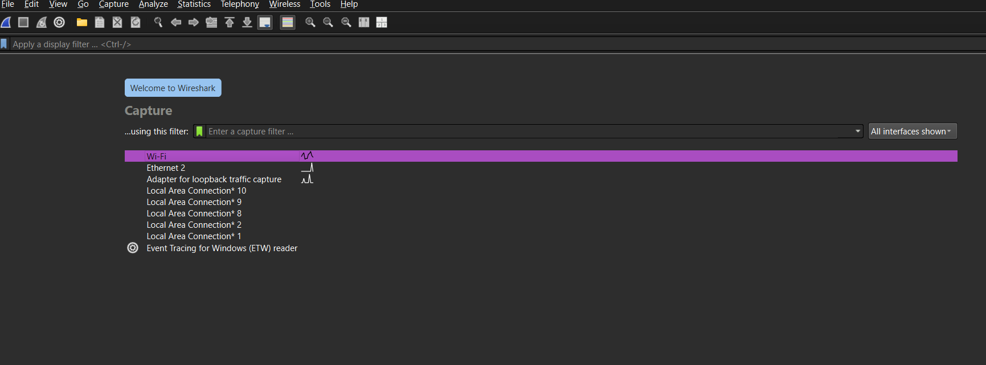

Click start for capturing.

After capturing the network traffic in Wireshark , that file is saved as below:

